

Course Title : Computer Networking Lab
Course Code : CSE342
Section : 1

Project

Project Title : Implementing DHCP and DNS Services.

Submitted By :
Name : Md. Raihan Shikder
ID : 2021200000089
Batch : 59
Department of CSE

Submitted To :
Name : Mr. Eamir Ahmed
Senior Lecturer, Department of Computer Science & Engineering
Southeast University

Table of Contents

- Introduction
- Objectives
- Network Topology
- Configuration Steps
  - Router Configuration
  - DHCP & DNS server configuration
  - Switch configuration
  - PC configuration
- Testing the configuration
- Conclusion

Introduction

Cisco Packet Tracer is a network simulation tool developed by Cisco Systems that allows users to create, configure, and troubleshoot virtual networks. It is used for educational purposes. Students can learn about networking and demonstrate them.
Implementing Dynamic Host Configuration Protocol (DHCP) and Domain Name System (DNS) services with the help of Cisco Packet Tracer. The objective is to create a functional network that automates IP address allocation through DHCP and resolves domain names via a DNS server. By configuring these, it will make network management easy and more efficient.

Objectives

- To configure a DHCP server to automatically assign IP addresses to PCs.
- To set up a DNS server to resolve domain names to IP addresses.

Network Topology

Devices and Tools:
Router | 1
DHCP & DNS Server | 1
Switches | 2
PCs | 10

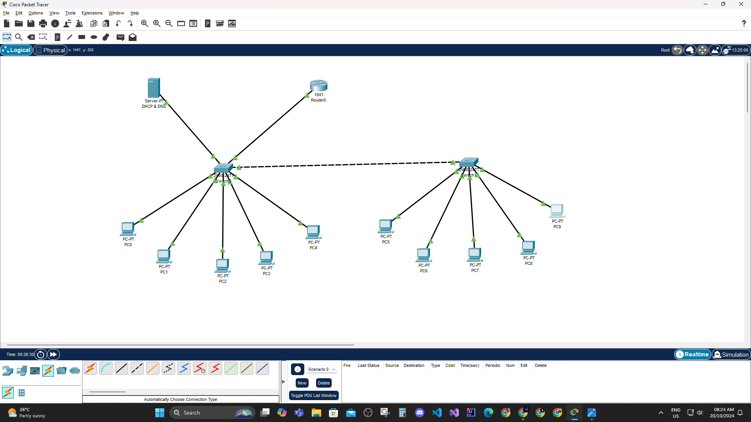

Configuration

Step 1: Open Cisco Packet Tracer.
Step 2: Then 1 Router taken and configured.
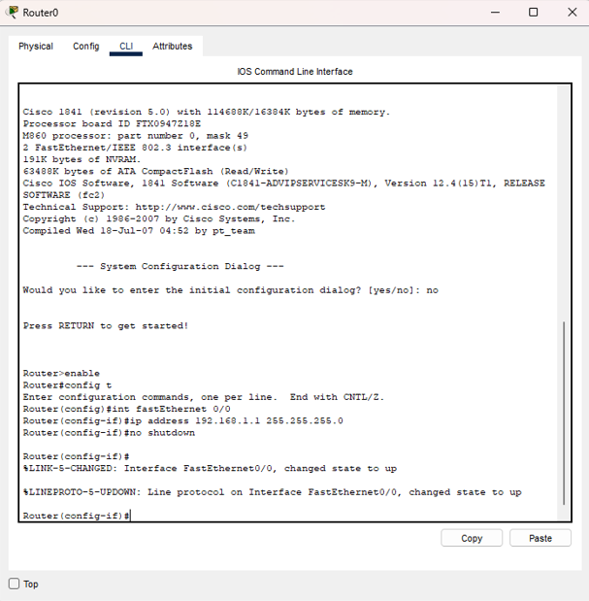
Ip address given to the router is: 192.168.1.1
Subnet Mask: 255.255.255.0

Step 3: 2 Switches have been taken. 1 Switch is connected with the router and both switches are connected to each other with cross-over cable.
Step 4: 1 server is taken. Set up the server for DHCP and DNS.
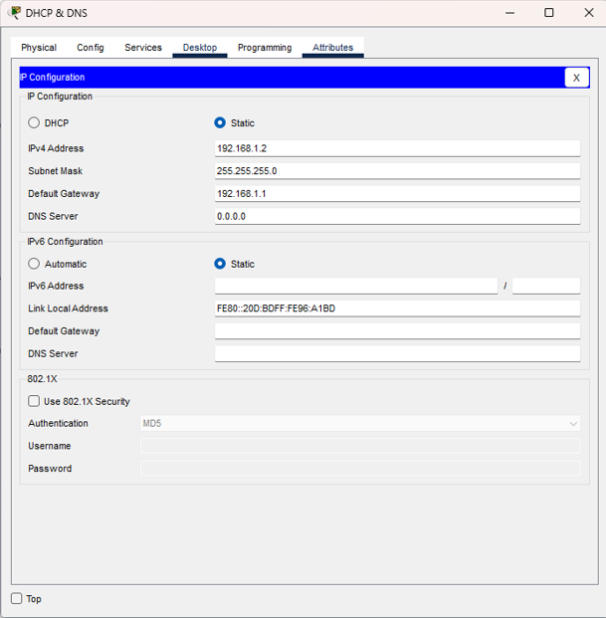
Ip configuration of the server is given.
Server Ip Address: 192.168.1.2
Subnet Mask: 255.255.255.0
Default Gateway: 192.168.1.1
Step 5: Turning On the DHCP & DNS of the server. Then configured the server. Given Addresses are:
Pool Name: serverPool.
Default Gateway: 192.168.1.1
DNS server: 192.168.1.2
Start IP: 192.168.1.0
Subnet Mask: 255.255.255.0
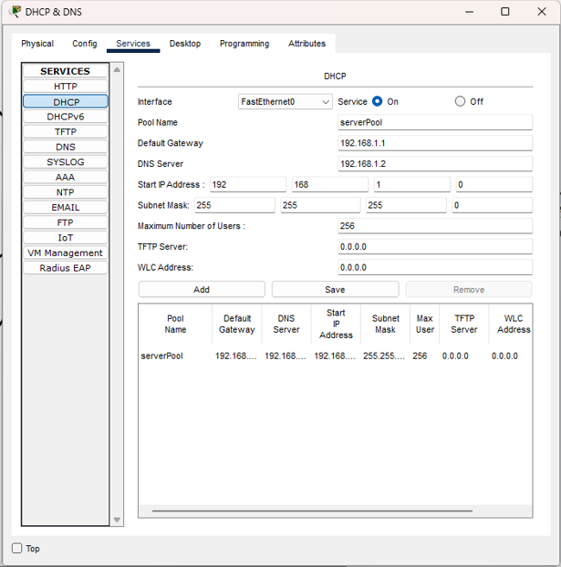
Saved.
Step 6: Then turning On the DNS option and given a Domain name and an address to it.
Domain Name: netlab.com
Address: 192.168.1.2
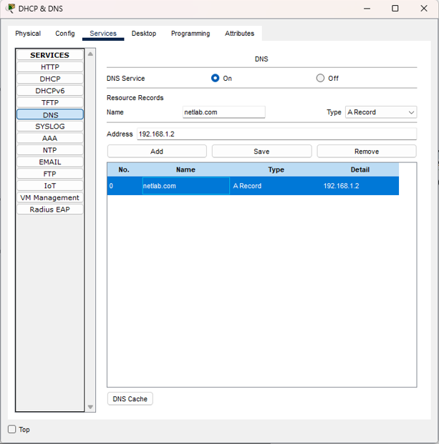
Save it.

Step 7: Then taken 10 PCs. 5 PC is connected to 1 switch and 5 PC is connected to another switch.
Now Configured the ip address of every PCs in the same way.
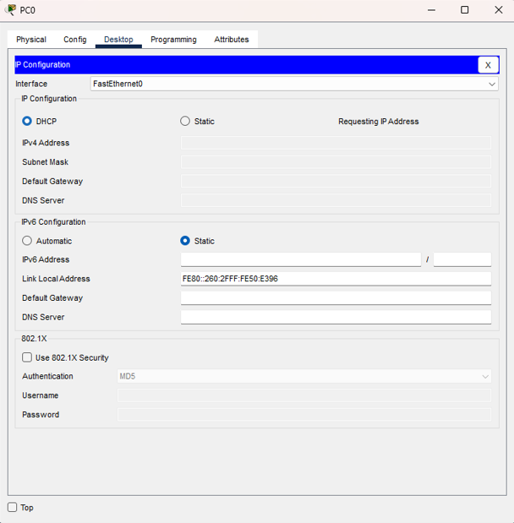
When the DHCP option is clicked it is requesting for IP addresses.
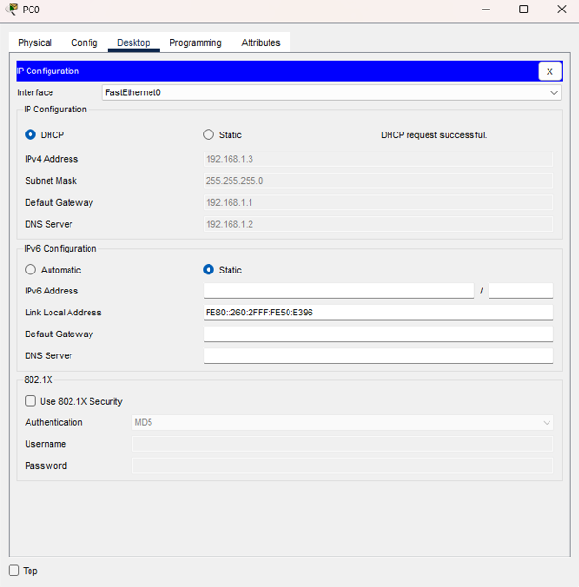
Automatically IP addresses are given to the PC.
Same way other PCs are given IP Addresses.

Testing Configuration

Step 1: Then checked if the server is responding or not.
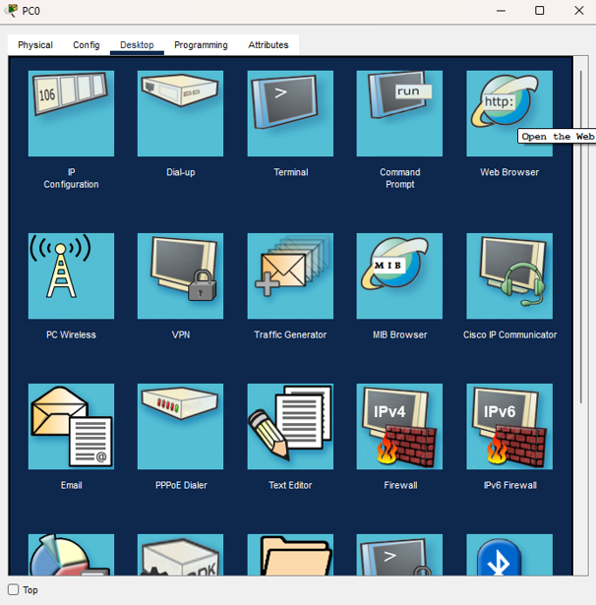
Goes to Web Browser.

Then typed the server address: 192.168.1.2
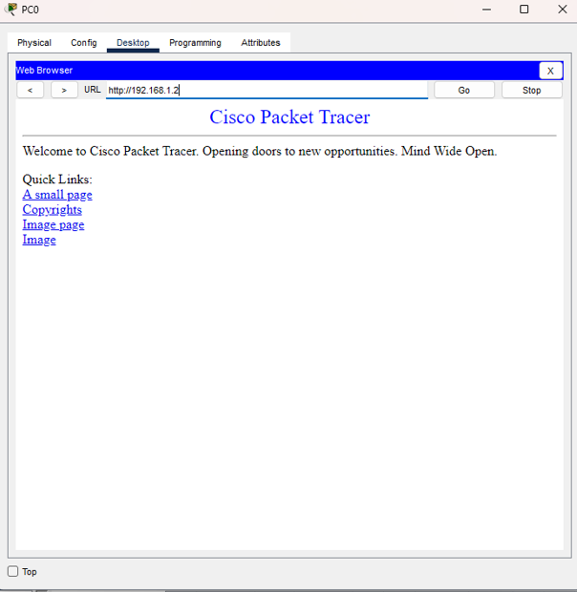
The server is responding with the IP address.

Step 2: Then check with the Domain Name that was given to the server.

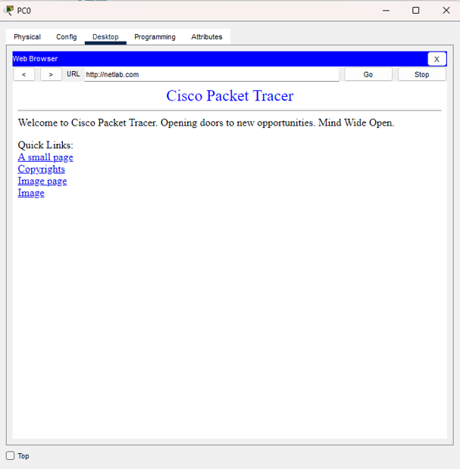
The server is responding with the Domain Name.

The IP Addresses are:

Device | IP Address | Subnet Mask
Router | 192.168.1.1 | 255.255.255.0
Server | 192.168.1.2 | 255.255.255.0

PCs IP addresses:

Devices | IP Address | Subnet Mask | Default Gateway | DNS
PC0 | 192.168.1.3 | 255.255.255.0 | 192.168.1.1 | 192.168.1.2
PC1 | 192.168.1.4 | 255.255.255.0 | 192.168.1.1 | 192.168.1.2
PC2 | 192.168.1.5 | 255.255.255.0 | 192.168.1.1 | 192.168.1.2
PC3 | 192.168.1.6 | 255.255.255.0 | 192.168.1.1 | 192.168.1.2
PC4 | 192.168.1.7 | 255.255.255.0 | 192.168.1.1 | 192.168.1.2
PC5 | 192.168.1.8 | 255.255.255.0 | 192.168.1.1 | 192.168.1.2
PC6 | 192.168.1.9 | 255.255.255.0 | 192.168.1.1 | 192.168.1.2
PC7 | 192.168.1.10 | 255.255.255.0 | 192.168.1.1 | 192.168.1.2
PC8 | 192.168.1.11 | 255.255.255.0 | 192.168.1.1 | 192.168.1.2
PC9 | 192.168.1.12 | 255.255.255.0 | 192.168.1.1 | 192.168.1.2

Conclusion

This project successfully implemented DHCP and DNS services in Cisco Packet Tracer, demonstrating their vital roles in network management. By automating IP address allocation and simplifying domain name resolution, we improved network efficiency and usability.

